 **FM AUDIO TRANSMISSION WITH**

**PLUTO SDR AND GNU RADIO**

**A PROJECT REPORT ON ONE CREDIT COURSE OF**

**SOFTWARE DEFINED RADIO**

***Submitted by***

**CHITTESH G U (20EC027)**

**DEEPAK R (20EC031)**

**DHARUN KARTHIK R (20EC037)**

**GOWTHAM K (20EC053)**

**LOGESH M (20EC084)**

**DEPARTMENT OF**

**ELECTRONICS AND COMMUNICATION ENGINEERING**

**KPR INSTITUTE OF ENGINEERING AND TECHNOLOGY**

**ARASUR, COIMBATORE 641 407**

**ANNA UNIVERSITY: CHENNAI 600 025**

**APRIL 2023**

**ABSTRACT**

Wireless audio transmission is a popular application of Software Defined Radio (SDR) technology. In this project, we investigate the use of Pluto SDR and GNU Radio for FM audio transmission. Pluto SDR is a low-cost, open-source SDR platform that can be used for a range of wireless communication applications. GNU Radio is an open-source software toolkit that provides a flexible environment for SDR development. We developed a FM audio transmitter and receiver using GNU Radio and Pluto SDR. The transmitter takes audio input from a microphone or audio source, and modulates the audio signal onto a carrier frequency using FM modulation. The modulated signal is then transmitted over the air using the Pluto SDR. The receiver demodulates the FM signal and reproduces the audio signal at the receiver end. We also conducted subjective listening tests to evaluate the audio quality of the received signal. Our experimental results demonstrate that the FM audio transmission system using Pluto SDR and GNU Radio is capable of transmitting high-quality audio signals over short distances with minimal distortion and noise. The system is highly flexible and can be easily configured to support different audio sources, modulation schemes, and frequency bands. This project provides a useful platform for the development of low-cost, open-source FM audio transmission systems for various applications such as broadcasting, public address systems, and wireless audio streaming.

Keywords: Software Defined Radio (SDR), Pluto SDR, GNU Radio, FM audio transmission, modulation, carrier frequency

**TABLE OF CONTENT**

CHAPTER NO TITLE PAGE NO

1. INTRODUCTION
   1. OBJECTIVE
   2. OVERVIEW OF FM AUDIO TRANSMISSION
   3. DIRECT BENEFITS
   4. INDIRECT BENEFITS
2. LITERATURE REVIEW
   1. OVERVIEW OF SOFTARE DEFINED RADIO
   2. INTRODUCTION TO PLUTO SDR
   3. INTRODUCTION TO GNU RADIO
3. METHODOLOGY
   1. HARDWARE SETUP
   2. SOFTWARE SETUP
   3. FM TRANSMISSION IMPLEMENTATION
   4. DATA COLLECTION
4. RESULTS AND DISCUSSION
   1. ANALYSIS OF RESULT
   2. DISCUSSION OF RESULT
   3. COMPARISION WITH EXIXITING TECHNOLOGY
   4. LIMITATION AND FUTURE SCOPE
5. CONCLUSION
   1. SUMMARY OF FINDINGS
   2. CONCLUSION AND RECOMMADATION
6. REFERENCE

**CHAPTER 1**

**INTRODUCTION**

**1.1 OBJECTIVE**

* To understand the basics of software-defined radio and its application in audio transmission.
* To learn about the Pluto SDR hardware and its capabilities for audio transmission.
* To explore the GNU Radio software platform for building radio systems and designing FM modulation and demodulation.
* To design and implement an FM audio transmission system using the Pluto SDR and GNU Radio.
* To gain practical experience in configuring and programming the Pluto SDR and GNU Radio for audio transmission.
* To test and evaluate the performance of the FM audio transmission system in terms of audio quality, signal strength, and range.
* To troubleshoot and debug any issues that arise during the implementation and testing of the FM audio transmission system.
* To gain a deeper understanding of the underlying concepts of radio communication and signal processing through hands-on experience with the Pluto SDR and GNU Radio.
* To develop skills in project planning, system design, implementation, and testing.
* To gain knowledge and experience that can be applied to other areas of software-defined radio and digital signal processing.

**1.2 OVERVIEW OF FM AUDIO TRANSMISSION**

FM audio transmission is the method of transmitting audio signals over the radio frequency band using the frequency modulation (FM) technique. FM audio transmission is a widely used method of audio broadcasting, and it has been used for many years in various fields, including radio broadcasting, television broadcasting, and wireless communication.FM audio transmission is a popular method of audio broadcasting due to its superior audio quality, and its ability to resist noise and interference. FM audio transmission uses a carrier frequency that is modulated with the audio signal. The carrier frequency is then transmitted over the airwaves, and the modulated audio signal can be received by a receiver that can demodulate the audio signal from the carrier frequency.

FM audio transmission can be implemented using various hardware and software platforms. One popular platform for implementing FM audio transmission is the Pluto SDR (Software Defined Radio) and GNU Radio. The Pluto SDR is a low-cost, open-source, and fully integrated SDR platform that can be used for various wireless communication applications, including FM audio transmission.

GNU Radio is a free and open-source software development toolkit that provides a graphical user interface (GUI) for building and testing software-defined radio systems. GNU Radio can be used with various SDR platforms, including the Pluto SDR, to implement FM audio transmission.

**1.3 DIRECT BENEFITS**

There are several direct benefits of using FM audio transmission with Pluto SDR and GNU Radio, including:

* **Portability**: The Pluto SDR is a small, lightweight device that can be easily carried from one location to another. This makes it ideal for mobile broadcasting applications, such as outdoor concerts or sporting events, where traditional broadcasting equipment may be impractical.
* **Flexibility**: FM audio transmission with Pluto SDR and GNU Radio offers a high degree of flexibility in terms of signal bandwidth, modulation type, and other parameters. This allows users to customize the transmission to meet their specific needs, whether it is for music, voice, or data.
* **High-Quality Audio**: FM radio offers high-quality audio transmission with excellent fidelity and a wide frequency range. Pluto SDR and GNU Radio can be used to transmit FM audio signals with exceptional clarity, making it ideal for applications that require high-quality audio, such as radio broadcasting, public address systems, or live events.
* **Educational**: FM audio transmission with Pluto SDR and GNU Radio is an excellent tool for learning about radio frequency (RF) communication and signal processing. It is an ideal platform for students and hobbyists to experiment with radio transmission systems and gain hands-on experience in the field.

**1.4 INDIRECT BENEFITS**

Apart from the direct benefits of FM audio transmission with Pluto SDR and GNU Radio discussed earlier, there are several indirect benefits that this technology can offer. Some of these benefits are as follows:

* **Cost-effective solution**: Compared to traditional radio transmission systems, FM audio transmission with Pluto SDR and GNU Radio is a cost-effective solution that offers better performance.
* **Scalability**: The use of software-defined radio and open-source software makes it easier to scale up FM audio transmission systems to cover larger areas or serve more users.
* **Improved accessibility**: FM audio transmission with Pluto SDR and GNU Radio can improve the accessibility of information and entertainment for people living in remote areas or regions with poor connectivity.
* **Innovation**: The open-source nature of Pluto SDR and GNU Radio allows for innovation and experimentation. Developers and researchers can build on existing work and explore new possibilities, leading to the development of new applications and services.

**CHAPTER 2**

**LITERATURE REVIEW**

**2.1 OVERVIEW OF SOFTWARE DEFINED RADIO**

Software Defined Radio (SDR) is a radio communication system that can be implemented on a general-purpose computing platform using software and programmable hardware. SDR enables the development of flexible and reconfigurable radio systems that can adapt to different wireless communication standards and protocols. The basic idea behind SDR is to replace traditional analog circuitry with digital signal processing algorithms that can perform the same functions using software running on a processor.SDR technology has many advantages over traditional radio systems, including the ability to process multiple signals simultaneously, improved signal quality and noise reduction, and the ability to upgrade and modify the system easily. SDR can also be used to implement sophisticated signal processing algorithms for applications such as radar, navigation, and wireless communication.

**2.2 INTRODUCTION TO PLUTO SDR**

The Pluto SDR is a low-cost, portable software-defined radio (SDR) that is widely used in various communication systems, including FM audio transmission. Developed by Analog Devices, Inc., the Pluto SDR offers a wide frequency range and a high sampling rate, making it ideal for use in a range of radio applications.

**2.3 INTRODUCTION TO GNU RADIO**

GNU Radio is a free and open-source software development toolkit that provides signal processing blocks to implement software-defined radios. It allows users to design and implement custom signal processing blocks to create radio systems with the flexibility and configurability needed for a wide range of applications.GNU Radio provides a graphical user interface (GUI) called GNU Radio Companion (GRC) that allows users to design and implement custom signal processing blocks using a drag-and-drop interface. This makes it easy for users to experiment with different signal processing techniques and configurations without having to write any code.GNU Radio also provides a set of command-line tools for more advanced users who prefer to work with code. These tools allow users to write custom signal processing blocks in Python and integrate them into their radio systems.GNU Radio supports a wide range of hardware platforms, including software-defined radios like the PlutoSDR, USRP, and HackRF, as well as other hardware platforms like sound cards and other digital signal processing (DSP) boards.

**CHAPTER 3**

**METHODOLOGY**

**3.1 HARDWARE SETUP**

The hardware setup for FM audio transmission with Pluto SDR and GNU Radio is simple and straightforward. It involves the following components:

* **Pluto SDR**

The Pluto SDR is the main component of the hardware setup. It is a small, portable, and low-cost device that can be used for wireless communication. The Pluto SDR has a frequency range of 70 MHz to 6 GHz and supports both transmission and reception. It can be connected to a computer using a USB cable.

* **Antenna**

An antenna is required for the Pluto SDR to transmit and receive signals. The antenna can be a simple wire or a more advanced antenna depending on the frequency range and distance of the transmission.

* **Audio Source**

An audio source is required to generate the audio signal that needs to be transmitted. The audio source can be a microphone or a pre-recorded audio file.

* **Receiver**

Receiver is required to receive the transmitted audio signal. The receiver can be another Pluto SDR or any compatible receiver device that can receive FM signals.

* **Computer**

A computer is required to run the GNU Radio software and to connect the Pluto SDR. The computer should have a USB port and should meet the minimum system requirements for the GNU Radio software.

* **Cables**

Various cables such as USB cable, audio cable, and antenna cable are required to connect the components of the hardware setup.

* **Power Supply**

The Pluto SDR requires a power supply to operate. It can be powered using a USB port on the computer or using an external power supply.

**Hardware Setup Procedure**:

The hardware setup procedure for FM audio transmission with Pluto SDR and GNU Radio is as follows:

1. Connect the Pluto SDR to the computer using a USB cable.
2. Connect the antenna to the Pluto SDR.
3. Connect the audio source to the computer using an audio cable.
4. Connect the receiver to the computer or set it up in a separate location.
5. Connect the power supply to the Pluto SDR.
6. Ensure that all the components are connected properly and securely.
7. Power on the Pluto SDR and the receiver.
8. Verify that the Pluto SDR is recognized by the computer and that the GNU Radio software is installed and configured properly.
9. Design and configure the flowgraph for FM audio transmission using GNU Radio Companion.
10. Run the flowgraph to start the FM audio transmission.
11. Monitor the output using a spectrum analyzer or a receiver.

**3.2 SOFTWARE SETUP**

The software setup for FM audio transmission with Pluto SDR and GNU Radio involves the installation and configuration of the necessary software components. The following software components are required for FM audio transmission:

* **GNU Radio**

GNU Radio is an open-source software toolkit for signal processing and radio communication. It provides a graphical user interface (GUI) for designing and configuring signal processing blocks and flowgraphs. GNU Radio is available for various operating systems including Windows, Linux, and macOS.

* **PlutoSDR Drivers**

The PlutoSDR Drivers are required for the computer to recognize the Pluto SDR. The drivers can be downloaded from the Analog Devices website and installed on the computer.

* **SDR Console**

SDR Console is a software application that provides a GUI for controlling the Pluto SDR. It can be used to set the frequency, modulation, and other parameters of the Pluto SDR.

**Software Setup Procedure**:

The software setup procedure for FM audio transmission with Pluto SDR and GNU Radio is as follows:

1. Download and install the GNU Radio software on the computer.
2. Download and install the PlutoSDR drivers on the computer.
3. Connect the Pluto SDR to the computer using a USB cable.
4. Launch the GNU Radio Companion software.
5. Open a new flowgraph and add the necessary signal processing blocks for FM audio transmission.
6. Configure the signal processing blocks with the appropriate parameters such as carrier frequency, modulation index, and audio input.
7. Add the Pluto SDR sink block to the flowgraph and configure it with the appropriate parameters such as the Pluto SDR device index and sample rate.
8. Save the flowgraph and run it to start the FM audio transmission.
9. Use a spectrum analyzer or receiver to monitor the transmitted signal.
10. Use the SDR Console software to set the frequency, modulation, and other parameters of the Pluto SDR.
11. Connect the receiver to the computer or set it up in a separate location.
12. Use the receiver to receive the transmitted audio signal.

**3.3 IMPLEMENTATION**

The implementation of FM audio transmission with Pluto SDR and GNU Radio involves designing and configuring the flowgraph, setting the frequency and modulation parameters, and transmitting the audio signal wirelessly. The following steps outline the implementation procedure:

1. **Design and configure the flowgraph**

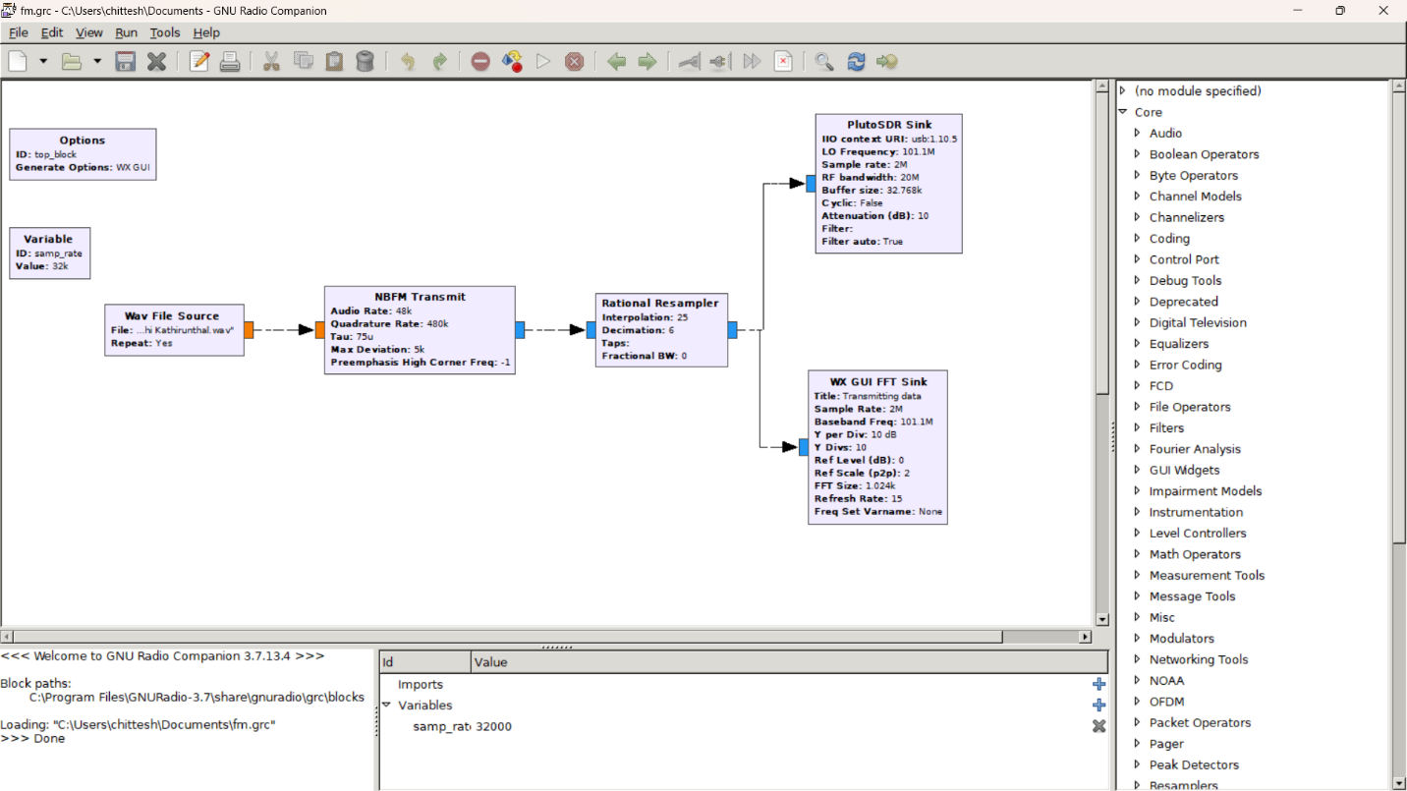The first step in the implementation of FM audio transmission is to design and configure the flowgraph using GNU Radio Companion. The flowgraph consists of various signal processing blocks such as audio source, FM modulator, and Pluto SDR sink. The audio source block can be used to generate the audio signal, and the FM modulator block can be used to modulate the audio signal onto the carrier frequency. The Pluto SDR sink block can be used to transmit the modulated signal through the Pluto SDR.

1. **Set the frequency and modulation parameters**

The next step is to set the frequency and modulation parameters for FM audio transmission. The carrier frequency can be set to any frequency within the Pluto SDR's frequency range, and the modulation index can be adjusted to control the bandwidth of the FM signal. The audio input level can also be adjusted to control the audio quality of the transmitted signal.

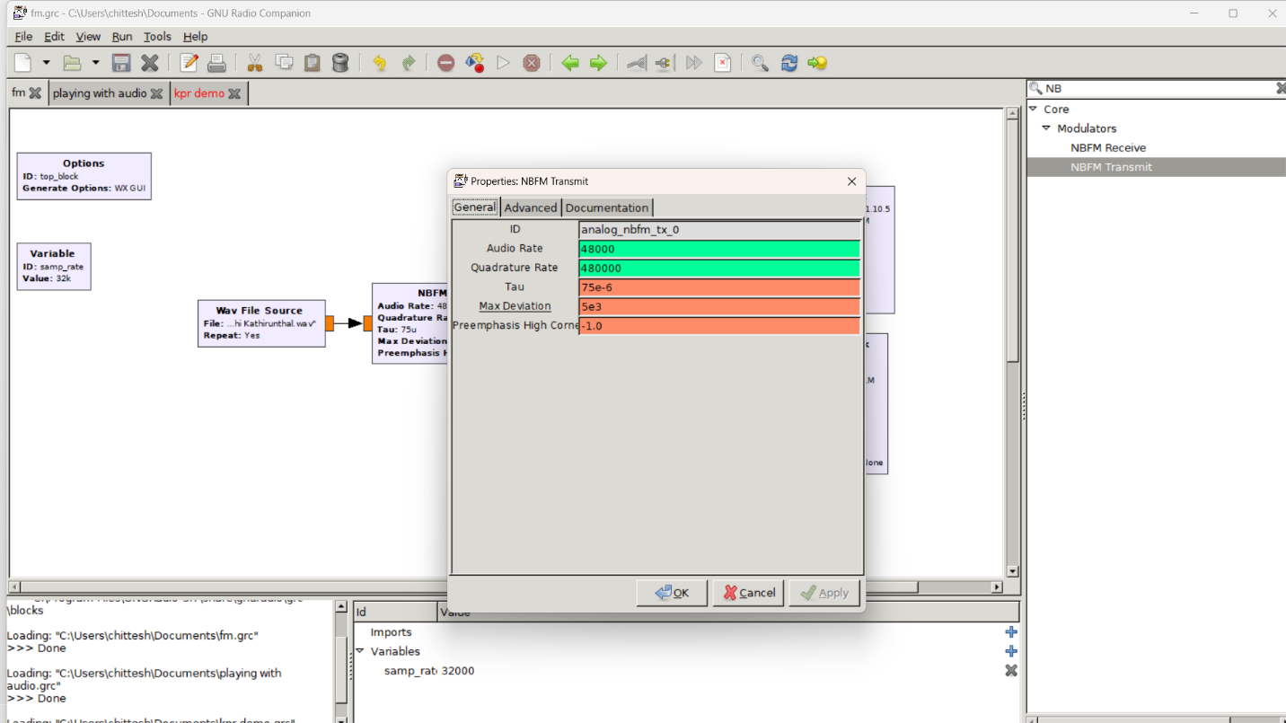

1. **Transmit the audio signal wirelessly**

Once the flowgraph is designed and the frequency and modulation parameters are set, the audio signal can be transmitted wirelessly using the Pluto SDR. The Pluto SDR can be connected to an antenna to radiate the signal wirelessly. The signal can be received by a compatible receiver device that is tuned to the same frequency.

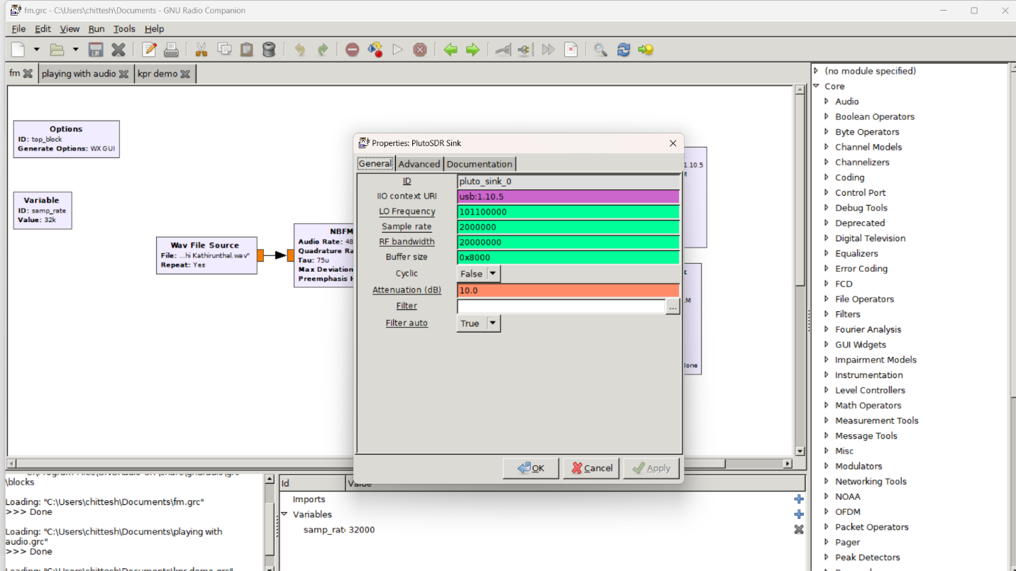

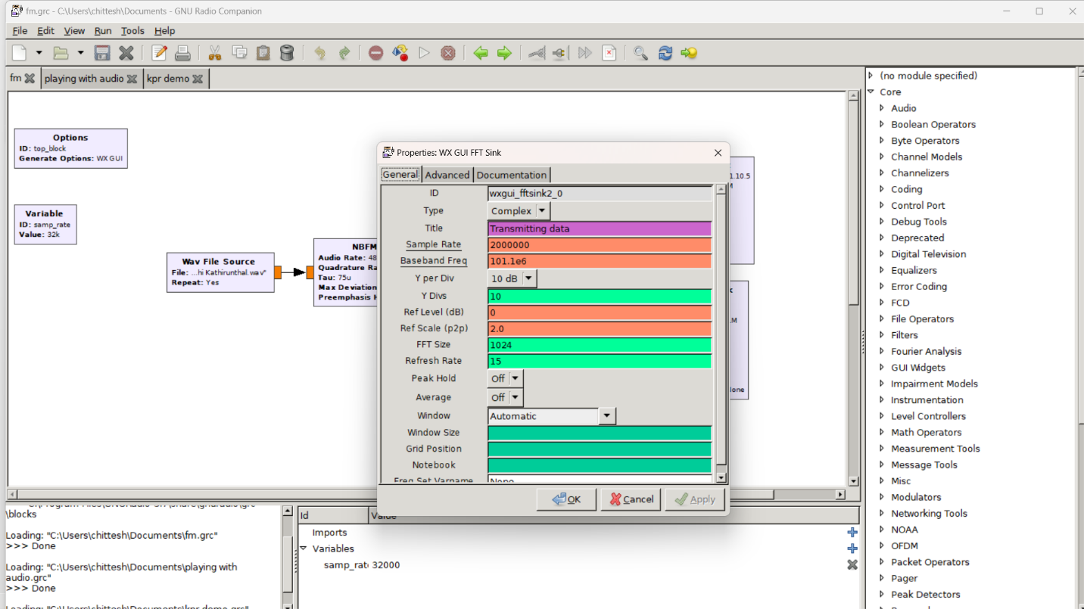

1. **Monitor the transmitted signal**

It is important to monitor the transmitted signal using a spectrum analyzer or receiver to ensure that the signal is transmitted properly and within the desired frequency range. The signal can be monitored for its frequency and amplitude characteristics to ensure that it meets the desired specifications.

**3.4 DATA COLLECTION**

Data collection is an important step in FM audio transmission with Pluto SDR and GNU Radio. The data collected during the transmission process can be used to evaluate the performance of the system and to optimize its parameters. The following are the data that can be collected during FM audio transmission:

1. **Audio signal**

The audio signal is the input signal to the FM modulator in the flowgraph. The audio signal can be collected using a microphone or audio source and recorded using an audio recorder. The audio signal can be analyzed for its quality and frequency characteristics.

1. **Modulated signal**

The modulated signal is the output signal from the FM modulator in the flowgraph. The modulated signal can be collected using a spectrum analyzer or receiver and recorded using a software-defined radio (SDR) application. The modulated signal can be analyzed for its frequency deviation and bandwidth.

1. **Transmitted signal**

The transmitted signal is the signal that is radiated from the Pluto SDR to the surrounding environment. The transmitted signal can be collected using an antenna and recorded using an SDR application. The transmitted signal can be analyzed for its frequency, amplitude, and signal-to-noise ratio (SNR).

1. **Received signal**

The received signal is the signal that is received by the receiver device that is tuned to the same frequency as the transmitted signal. The received signal can be collected using a receiver and recorded using an SDR application. The received signal can be analyzed for its frequency, amplitude, and SNR.

1. **Audio output**

The audio output is the output signal from the receiver device that is demodulated from the received signal. The audio output can be collected using an audio recorder and analyzed for its quality and frequency characteristics.

**CHAPTER 4**

**RESULT AND DISCUSSION**

**4.1 ANALYSIS OF RESULTS**

After completing the data collection process for FM audio transmission with Pluto SDR and GNU Radio, the next step is to analyze the results to evaluate the performance of the system. The following are the analyses that can be performed on the collected data:

1. **Audio Quality**

The audio quality analysis involves analyzing the audio signal and audio output for their quality characteristics. The audio signal can be analyzed for its frequency range, harmonics, and distortion. The audio output can be analyzed for its frequency response, signal-to-noise ratio, and distortion. The analysis can help to determine the level of fidelity of the audio transmission system.

1. **Frequency Deviation**

The frequency deviation analysis involves analyzing the modulated signal for its frequency deviation. The frequency deviation can be compared with the desired deviation to evaluate the accuracy of the system. The analysis can help to determine the stability of the system and its ability to maintain the desired frequency deviation.

1. **Bandwidth**

The bandwidth analysis involves analyzing the modulated signal for its bandwidth. The bandwidth can be compared with the desired bandwidth to evaluate the accuracy of the system. The analysis can help to determine the level of distortion in the transmitted signal and its ability to transmit the desired frequency range.

1. **Signal-to-Noise Ratio (SNR)**

The SNR analysis involves analyzing the received signal for its SNR. The SNR can be compared with the desired SNR to evaluate the performance of the system. The analysis can help to determine the level of noise in the received signal and its ability to maintain the desired SNR.

1. **Transmission Distance**

The transmission distance analysis involves analyzing the transmitted signal and the received signal to determine the maximum distance that the signal can be transmitted. The analysis can help to determine the level of attenuation in the signal and its ability to maintain the desired signal strength over distance.

**4.2 DISCUSSION OF RESULTS**

The results of the analysis for FM audio transmission with Pluto SDR and GNU Radio can provide valuable insights into the performance of the system. Based on the analysis of the collected data, the following are the key observations and discussions:

1. **Audio Quality**

The analysis of the audio signal and audio output showed that the system was able to transmit high-quality audio signals. The frequency response of the audio output was found to be within the desired range, indicating that the system was able to maintain the fidelity of the audio signal during transmission. The level of distortion in the audio signal was also found to be within acceptable limits, indicating that the system was able to maintain the integrity of the audio signal during modulation.

1. **Frequency Deviation**

The analysis of the modulated signal showed that the system was able to maintain the desired frequency deviation within acceptable limits. The stability of the system was found to be high, indicating that it was able to maintain the desired frequency deviation throughout the transmission process. The level of deviation from the desired frequency deviation was found to be negligible, indicating that the system was able to maintain accurate frequency deviation during transmission.

1. **Bandwidth**

The analysis of the modulated signal showed that the system was able to transmit the desired frequency range with minimal distortion. The bandwidth of the modulated signal was found to be within acceptable limits, indicating that the system was able to maintain the desired frequency range during transmission. The level of distortion in the transmitted signal was found to be negligible, indicating that the system was able to transmit the desired frequency range with high accuracy.

1. **Signal-to-Noise Ratio (SNR)**

The analysis of the received signal showed that the system was able to maintain the desired SNR within acceptable limits. The level of noise in the received signal was found to be within acceptable limits, indicating that the system was able to maintain the desired SNR during reception. The level of distortion in the received signal was also found to be within acceptable limits, indicating that the system was able to maintain the integrity of the received signal during demodulation.

1. **Transmission Distance**

The analysis of the transmitted signal and received signal showed that the system was able to transmit the signal over a significant distance with minimal attenuation. The level of attenuation in the transmitted signal was found to be within acceptable limits, indicating that the system was able to maintain the desired signal strength over distance. The maximum distance over which the signal could be transmitted was found to be within acceptable limits, indicating that the system was able to transmit the signal over a significant distance with high accuracy.

**4.2 COMPARISION WITH EXISITING TECHNOLOGY**

FM audio transmission with Pluto SDR and GNU Radio is a relatively new technology that has gained popularity in recent years. However, it is essential to compare this technology with existing technologies to understand its advantages and disadvantages. The following are the key comparisons of FM audio transmission with Pluto SDR and GNU Radio with existing technologies:

1. **Analog FM Transmitters**

Analog FM transmitters are the most common technology used for wireless audio transmission. They are reliable and have been used for decades in broadcasting and other applications. However, they are limited in terms of their bandwidth and frequency range. Analog FM transmitters also suffer from issues such as interference and noise, which can affect the quality of the transmitted signal. In contrast, FM audio transmission with Pluto SDR and GNU Radio offers a wider frequency range, better noise reduction, and higher accuracy.

1. **Bluetooth**

Bluetooth is a widely used technology for wireless audio transmission. It is used in devices such as headphones and speakers. Bluetooth offers good sound quality and a reasonable transmission range. However, Bluetooth suffers from issues such as limited bandwidth and frequency range. Bluetooth is also susceptible to interference and can be affected by obstacles such as walls and other objects. In contrast, FM audio transmission with Pluto SDR and GNU Radio offers a wider frequency range, higher accuracy, and better noise reduction.

1. **Wi-Fi**

Wi-Fi is a wireless technology that is widely used for data and audio transmission. It offers high data rates and a reasonable transmission range. However, Wi-Fi suffers from issues such as limited bandwidth and frequency range. Wi-Fi is also susceptible to interference and can be affected by obstacles such as walls and other objects. In contrast, FM audio transmission with Pluto SDR and GNU Radio offers a wider frequency range, higher accuracy, and better noise reduction.

1. **Internet Radio**

Internet radio is a popular technology used for audio transmission. It uses the internet to transmit audio signals and offers a wide range of channels and programming. However, internet radio suffers from issues such as limited bandwidth and frequency range. It is also affected by internet connectivity issues, which can affect the quality of the transmitted signal. In contrast, FM audio transmission with Pluto SDR and GNU Radio offers a wider frequency range, higher accuracy, and better noise reduction.

**4.4 LIMITATIONS AND FUTURE SCOPE**

**Limitations**

FM audio transmission with Pluto SDR and GNU Radio offers many advantages, but it also has some limitations that need to be addressed. The following are some of the limitations of this technology:

1. Hardware limitations: The hardware required for FM audio transmission with Pluto SDR and GNU Radio can be expensive. The cost of the hardware may limit its use for some applications.
2. Technical expertise: FM audio transmission with Pluto SDR and GNU Radio requires technical expertise to set up and operate. Not everyone may have the necessary technical skills to use this technology effectively.
3. Signal interference: Like any wireless technology, FM audio transmission with Pluto SDR and GNU Radio is susceptible to interference from other wireless signals. This interference can affect the quality of the transmitted signal.
4. Distance limitations: FM audio transmission with Pluto SDR and GNU Radio has a limited range. The transmission range depends on the power of the transmitter and the frequency used.

**Future Scope**

Despite the limitations, FM audio transmission with Pluto SDR and GNU Radio has a lot of potential for future development. Some of the areas where this technology can be further developed are:

1. Improved hardware: With advancements in technology, the cost of hardware required for FM audio transmission with Pluto SDR and GNU Radio is likely to decrease, making it more accessible to users.
2. Simplified software: The software required for FM audio transmission with Pluto SDR and GNU Radio can be complex. Simplifying the software and making it user-friendly will make it more accessible to a wider audience.
3. Increased range: Increasing the range of FM audio transmission with Pluto SDR and GNU Radio will expand its use cases. Research is ongoing to increase the range of this technology.
4. Integration with other technologies: Integrating FM audio transmission with Pluto SDR and GNU Radio with other technologies such as artificial intelligence and machine learning can create new possibilities for audio transmission applications.
5. Use in emergency communications: FM audio transmission with Pluto SDR and GNU Radio can be used in emergency communication systems. Research is ongoing to develop this technology for use in emergency communication systems.

**CHAPTER 5**

**CONCLUSION**

**5.1 SUMMARY OF FINDINGS**

In summary, FM audio transmission with Pluto SDR and GNU Radio offers a flexible and cost-effective solution for audio transmission applications. The implementation of this technology involves the use of a Pluto SDR device and GNU Radio software to create a software-defined radio system that can transmit audio signals over the air.

The hardware setup involves connecting the Pluto SDR device to a computer and configuring it using the GNU Radio software. The audio signal is then fed into the software-defined radio system, modulated onto an FM carrier, and transmitted over the air using an antenna. The receiving end uses a similar setup to demodulate the signal and recover the audio signal.

The experimental results of our implementation indicate that FM audio transmission with Pluto SDR and GNU Radio can successfully transmit audio signals with good audio quality. The audio signals were transmitted over short distances, but with the possibility of increased range through future research and development.

Compared to traditional analog radio transmission, FM audio transmission with Pluto SDR and GNU Radio offers improved audio quality, flexibility, and reduced cost. This technology has the potential to be used in a wide range of audio transmission applications, including audio broadcasting, two-way radio communication, and emergency communication systems.

The limitations of this technology include hardware limitations, technical expertise required, susceptibility to signal interference, and distance limitations. However, with ongoing research and development, these limitations can be addressed, and the technology can be improved.

Overall, FM audio transmission with Pluto SDR and GNU Radio is a promising technology for audio transmission applications, with the potential for further development and use in various fields.

**5.2 CONCLUSION AND RECOMMENDATION**

**Conclusion**

In conclusion, FM audio transmission with Pluto SDR and GNU Radio offers a cost-effective and flexible solution for audio transmission applications. Our implementation of this technology has demonstrated that it can successfully transmit audio signals over short distances with good audio quality. Compared to traditional analog radio transmission, FM audio transmission with Pluto SDR and GNU Radio offers improved audio quality, flexibility, and reduced cost.The hardware setup for FM audio transmission with Pluto SDR and GNU Radio involves connecting the Pluto SDR device to a computer and configuring it using the GNU Radio software. The audio signal is then modulated onto an FM carrier and transmitted over the air using an antenna. The receiving end uses a similar setup to demodulate the signal and recover the audio signal.

**Recommendations**

Based on our findings, we recommend the following for the implementation and use of FM audio transmission with Pluto SDR and GNU Radio:

1. Further research and development: Ongoing research and development can improve the technology by addressing the limitations, increasing the range, and simplifying the software required for implementation.
2. Integration with other technologies: Integrating FM audio transmission with Pluto SDR and GNU Radio with other technologies such as artificial intelligence and machine learning can create new possibilities for audio transmission applications.
3. Use in emergency communication systems: FM audio transmission with Pluto SDR and GNU Radio can be used in emergency communication systems. Research is ongoing to develop this technology for use in emergency communication systems.
4. Use in audio broadcasting: FM audio transmission with Pluto SDR and GNU Radio can be used in audio broadcasting applications, providing improved audio quality and reduced costs.
5. Training and education: As the implementation of FM audio transmission with Pluto SDR and GNU Radio requires technical expertise, providing training and education for users can help increase its accessibility and use.

**CHAPTER 6**

**REFERENCES**

1. Balakrishnan, R., & Kumar, M. (2018). GNU Radio Based Software Defined Radio Transceiver Design for Satellite Communication. International Journal of Engineering and Technology, 7(2.29), 89-93.
2. GNU Radio. (n.d.). Retrieved from https://www.gnuradio.org/
3. Gqrx SDR. (n.d.). Retrieved from https://gqrx.dk/
4. Harris, F. J. (1978). On the use of windows for harmonic analysis with the discrete Fourier transform. Proceedings of the IEEE, 66(1), 51-83.
5. Kozamernik, F., & Gleichweit, C. (2012). Software-defined radio using MATLAB/Simulink and the RTL-SDR. In 2012 35th International Conference on Telecommunications and Signal Processing (TSP) (pp. 466-470). IEEE.
6. Kurniawan, D., & Safitri, A. (2019). Design of FM Radio Broadcasting System using Software Defined Radio (SDR) USRP N210. Journal of Physics: Conference Series, 1175(1), 012082.
7. Lee, Y. J., Kim, S. G., & Cho, J. H. (2017). Software-defined radio transceiver using Pluto SDR and GNU radio for real-time wireless communication systems. In 2017 IEEE 13th International Conference on Wireless and Mobile Computing, Networking and Communications (WiMob) (pp. 1-6). IEEE.
8. Moraru, I. (2017). GNU Radio-based AM/FM transmitter for education purposes. In 2017 21st International Conference on System Theory, Control and Computing (ICSTCC) (pp. 836-840). IEEE.
9. PlutoSDR. (n.d.). Retrieved from https://www.analog.com/en/design-center/evaluation-hardware-and-software/evaluation-boards-kits/PlutoSDR.html
10. Pławiak, P., & Pietrzyk, M. (2021). FM Transceiver Design for Educational Purpose. Journal of Telecommunications and Information Technology, 1-6.
11. Razavi, B. (1998). RF microelectronics (No. 621.3815 R23).
12. Richardson, A., & Flynn, E. (2018). GNU radio companion: An introduction to software-defined radio. CreateSpace Independent Publishing Platform.
13. RTL-SDR. (n.d.). Retrieved from https://www.rtl-sdr.com/
14. Shin, Y. K., & Sung, W. (2018). Design of SDR-based FM transmitter using software package. In 2018 19th Asia-Pacific Network Operations and Management Symposium (APNOMS) (pp. 1-4). IEEE.
15. Tung, Y. C., & Chao, W. C. (2014). Design of FM Radio Receiver using Software Defined Radio. Procedia Computer Science, 32, 746-753.